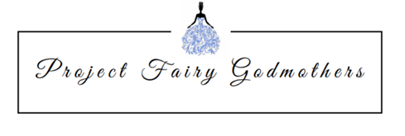

DONATION RECEIPT

Date: _____________________
Name: _________________________________________
Address: ________________________________________
Donation Description:
QTY
________ Prom Dresses
________ Shoes
_________ Jewelry
_________ Accessories
_________ Other: Description _________________________________________________

Project Fairy Godmothers Authorized Signature: Mary K Thielen
Project Fairy Godmothers is a 501(c)3 nonprofit organization. Federal law prohibits PFG from declaring monetary value for purposes of tax donation. Donor is requested to establish value for tax purposes. No goods or services were provided in exchange for this donation. This donation is made with the understanding that the donee organization has complete control and administration over the use of the donated items. Tax ID 84-3259066

