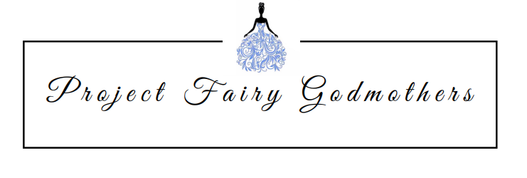

Thank you for your contribution of __________________ [Description of Item] that Project Fairy Godmothers, a 501(c)(3) not for profit organization, received on ___/____/___[Date]. No goods or services were provided in exchange for your contribution.

Please contact us at projectfairygodmothers@gmail.com if you have any questions.

We appreciate your support of our organizations – without you we could not make prom dreams come true.

